&

“Connecting the dots to make sense of data”


N.V.SANDEEP , N.SAI GIRISH
III/IV B.Tech (CSE)
Avanthi Institute of Engineering and Technology, Narsipatnam
E-mail:sandeepnara536@gmail.com, girish.9000001619@gmail.com,

CONTENTS
- Introduction
- Motivation for data mining
- Explaining data mining
- Data Mining: On what kind of data?
- Data mining functionality and Classification
- Major issues in data mining
- Article : Knowledge discovery in science as opposed to business
- Conclusion
- References



Abstract:

This era of human development has been rightfully called as the information age. Today, the world’s most valuable resource is information. With the advent of computers and since their inception, their boom has lead to overloading and overflowing of information. The world today faces an information crisis, where there is a lot of data and the vastness of the data causes chaos. The vast data which is out there in the cyberspace has to be properly organized in a way some “sense” could be implied from it. Thus the world today need a tool which “discovers knowledge” by interpreting given data. Observing the rightful need for something to properly organize and effectively use the data, the fields of data warehousing and data mining were incepted.
Data warehousing deals with “Subject-oriented, integrated, nonvolatile, time variant collection of data in support of management decisions”. Simply put, a data warehouse is a collection of snapshots of data taken from transaction processing systems at given intervals. Data warehouses are databases used solely for reporting. The data warehouse allows the storage of data in a format that facilitates its access thus enhancing the ability of business decision-makers to gain timely access to corporate information.
Data mining is the non-trivial extraction of implicit, previously unknown and potentially useful information from data. Data mining includes methodologies to interpret knowledge from the data such as exploration and analysis, by automatic and semi-automatic means, of large quantities of data in order to discover meaning patterns from the data.
This paper provides a brief introduction to the various aspects of data mining, putting data warehousing aside. This paper briefly introduces the basic concepts involved with data mining, like its definition, functionality, characteristics and the major issues. Finally the paper presents a real-time scenario- an article titled – “Knowledge discovery in science as opposed to business” which provides insightful information regarding the scope of data mining.

INTRODUCTION

“Knowledge is the ultimate competitive advantage”
- Donald Mitchell (from “The Ultimate Competitive Advantage: Secrets of Continuously Developing a More Profitable Business Model”)
Data is probably the most valuable resource of an enterprise. Whether the decision is Strategic, tactic or operational the data should be turned into ready-to-use and ready-to-operate information. Data that comes from the large inventories should be collected and warehoused in a system so that the past references are readily available. This data should be structured and optimized for querying and data analysis. This forms an essential part of a Data Warehousing .The Data Warehouse is a central repository of data that provides the user with integrated, up-to-date data from various administrative systems.
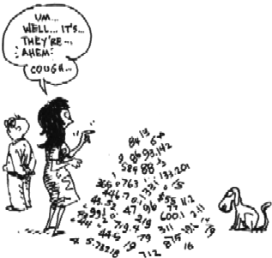
Data Mining is a powerful new technology with great potential to help companies focus on the most important information in the data they have collected about the behavior of their customers and potential customers. It discovers information within the data that Queries and reports can’t effectively reveal. This search may be done just by the user, i.e. just by performing queries, in which case it is quite hard and in most of the cases not comprehensive enough to reveal intricate patterns. Data mining uses sophisticated statistical analysis and modeling techniques to uncover such patterns and relationships hidden in organizational databases - patterns that ordinary methods might miss. Once found, the information needs to be presented in a suitable form, with graphs, reports, etc.

Motivation for data mining
“Necessity is the Mother of Invention” - Proverb
In recent past with the advent of internet boom and what came to be known as the “Information Age”, data has become very hard to manage. Automated data collection tools and mature database technology have lead to tremendous amounts of data stored in databases, data warehouses and other information repositories. We are currently overloaded with immense amount of information which is, largely unorganized and freely left in the cyber space to roam about without any purpose.
Quoting the words of Micheline Kamber “We are drowning in data, but starving for knowledge!”
The solution for this ‘massive’ problem at hand - Data warehousing and data mining.
Meaning, that we data warehouse and perform on-line analytical processing of the data in a sequential and organized fashion to optimally extract knowledge from the ‘heap’ of data. And also we extract interesting knowledge like rules, regularities, patterns, constraints from data in large databases in order to make some “sense” of the data and implication of data.
Explaining data mining
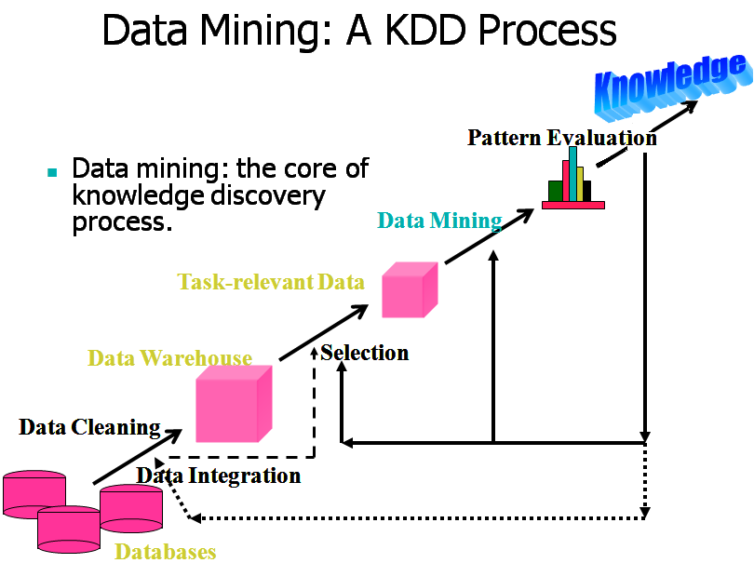
Discovery is the process of looking in a database to find hidden patterns without a predetermined idea or hypothesis about what the patterns may be. In other words, the program takes the initiative in finding what the interesting patterns are, without the user thinking of the relevant questions first. Former methods of discovery were done manually until data mining came into existence. Generally Data mining (sometimes called data or knowledge discovery) is the process of analyzing data from different perspectives and summarizing it into useful information - information that can be used to increase revenue, cuts costs, or both.
Data mining is a computer-assisted process of digging through and analyzing enormous sets of data and then extracting the meaning of the data to predict behaviors and future trends, allowing businesses to make proactive, knowledge-driven decisions. This stands as an answer to business questions that traditionally were too time consuming to resolve. Data mining algorithms scour databases for hidden patterns, finding predictive information that experts may miss because it lies outside their expectations. Technically, data mining is the process of finding correlations or patterns among dozens of fields in large relational database, Data warehouses, transactional databases, and advanced DB and information repositories. It is based on filtration and assaying of mountain of data “ore” in order to get “nuggets” of knowledge.

Data Mining: On what kind of data?
Data mining would be applied to any to any kind of data repository as well as transient data such as data streams. Thus the scope of data repository includes:
Relational databases
Data warehouses
Transactional databases
Advanced DB and information repositories like:
- Object-oriented and object-relational databases
- Spatial databases
- Time-series data and temporal data
- Text databases and multimedia databases
- Heterogeneous and legacy databases
- WWW

Data mining functionality And Classification
Data mining functionality are used to specify the kind of patterns found in data mining tasks. These fall into two categories
1. Descriptive
2. Predicative
Now data mining functionalities and the kind of patterns discovered by them are described below:
- Concept description: Characterization and discrimination
- Association (correlation and causality)
- Classification and Prediction
- Cluster analysis
Data mining methodologies can be categorized according to various criteria.

  - Kinds of databases to be mined
  - Kinds of knowledge to be discovered

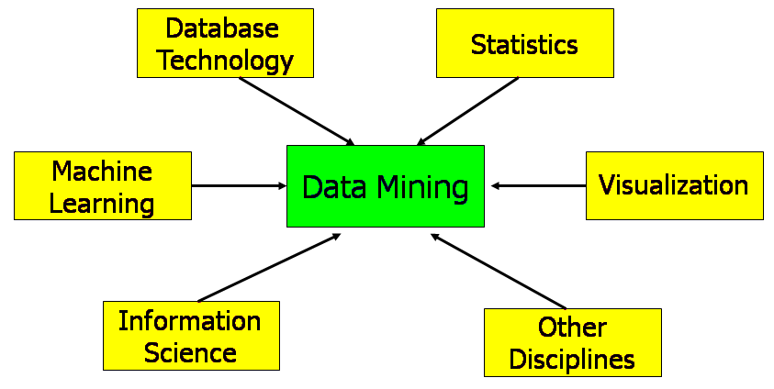

Major issues in data mining
Data mining is a young and a promising field. Due to its immaturity, there are a few shortcomings. They are:

- Mining methodology and user interaction
- Performance and scalability

- Issues relating to the diversity of data types

Article : Knowledge discovery in science as opposed to business

1. Introduction
Data Mining is the essential ingredient in the more general process of Knowledge Discovery in Databases (KDD). The idea is that by automatically sifting through large quantities of data it should be possible to extract nuggets of knowledge.
Data mining has become fashionable, not just in computer science (journals & conferences), but particularly in business IT. (An example is its promotion by television advertising .) The emergence is due to the growth in data warehouses and the realisation that this mass of operational data has the potential to be exploited as an extension of Business Intelligence.
Data mining offers a solution: automatic rule extraction. By searching through large amounts of data, one hopes to find sufficient instances of an association between data value occurrences to suggest a statistically significant rule. However, a domain expert is still needed to guide and evaluate the process and to apply the results.
2.Business Data Analysis
Popular commercial applications of data mining technology are, for example, in direct mail targeting, credit scoring, churn prediction, stock trading, fraud detection, and customer segmentation. It is closely allied to data warehousing in which large (gigabytes) corporate databases are constructed for decision support applications. Rather than relational databases with SQL, these are often multi-dimensional structures used for so-called on-line analytical processing (OLAP). Data mining is a step further from the directed questioning and reporting of OLAP in that the relevant results cannot be specified in advance.
3. Scientific Data Analysis
Rules generated by data mining are empirical - they are not physical laws. In most research in the sciences, one compares recorded data with a theory that is founded on an analytic expression of physical laws. The success or otherwise of the comparison is a test of the hypothesis of how nature works expressed as a mathematical formula. This might be something fundamental like an inverse square law. Alternatively, fitting a mathematical model to the data might determine physical parameters (such as a refractive index).
On the other hand, where there are no general theories, data mining techniques are valuable, especially where one has large quantities of data containing noisy patterns. This approach hopes to obtain a theoretical generalisation automatically from the data by means of induction, deriving empirical models and learning from examples. The resultant theory, while maybe not fundamental, can yield a good understanding of the physical process and can have great practical utility.
4. Scientific Applications
In a growing number of domains, the empirical or black box approach of data mining is good science. Three typical examples are:
1. Sequence analysis in bioinformatics
Genetic data such as the nucleotide sequences in genomic DNA are digital. However, experimental data are inherently noisy, making the search for patterns and the matching of sub-sequences difficult. Machine learning algorithms such as artificial neural nets and hidden Markov chains are a very attractive way to tackle this computationally demanding problem.
2. Classification of astronomical objects
The thousands of photographic plates that comprise a large survey of the night sky contain around a billion faint objects. Having measured the attributes of each object, the problem is to classify each object as a particular type of star or galaxy. Given the number of features to consider, as well as the huge number of objects, decision-tree learning algorithms have been found accurate and reliable for this task.
3. Medical decision support
Patient records collected for diagnosis and prognosis include symptoms, bodily measurements and laboratory test results. Machine learning methods have been applied to a variety of medical domains to improve decision-making. Examples are the induction of rules for early diagnosis of rheumatic diseases and neural nets to recognise the clustered micro-calcifications in digitised mammograms that can lead to cancer.
The common technique is the use of data instances or cases to generate an empirical algorithm that makes sense to the scientist and that can be put to practical use for recognition or prediction.

Conclusion
Data mining is still an area of current research, and its problems are not yet fully solved. Nonetheless, despite these difficulties, data mining offers an important approach to achieving values from the data warehouse for use in decision support. Data mining is emerging as one of the key features of many homeland security initiatives. Often used as a means for detecting fraud, assessing risk, and product

retailing, data mining involves the use of data analysis tools to discover previously unknown, valid patterns and relationships in large data sets. Data mining offers great promise in helping organizations uncover hidden patterns in their data and thus would play a major role in organization and evaluation of data and its patterns in the future.

REFERENCE

1. Jiawei Han and Micheline Kamber, Data mining concepts and techniques, Second edition
2. Tan, Steinbach, Kumar, Introduction to Data Mining
3. Marcello Rossi, Data Mining: Searching Knowledge in Data Warehouses, Università degli studi di Roma “La Sapienza” Facoltà di Ingegneria Informatica
4. Usama Fayyad, Gregory Piatetsky-Shapiro, and Padhraic Smyth, From Data Mining to Knowledge Discovery in Databases
5. David J. Hand, Heikki Mannila and Padhraic Smyth, Principles of Data Mining,The MIT Press (mitpress.mit.edu/026208290X)
6. Kurt Thearling, Dynamic and Analytic Technologies – (URL- http://www.thearling.com)
7. Joseph .M. Firestone, DKMS Brief No. Eleven: My Road to Knowledge Management and Data Mining through Data Warehousing
Weblinks:
- www.ats.ucla.edu/stat/ sas/topics/logistic_regression.htm
- www.indiana.edu/~statmath/stat/all/cat/1b1.htm
- luna.cas.usf.edu/~mbrannic/ files/regression/Logistic.html
- www.sas.com/technologies/analytics/ datamining/miner/dec_trees.html
- www.sas.com/offices/asiapacific/ sp/training/courses/dmdt.html
- citeseer.ist.psu.edu/36580.htm

- www.sas.com/technologies/analytics/ datamining/miner/neuralnet.html
- www.sas.com/offices/asiapacific/ sp/training/courses/dmnn.html
- dimacs.rutgers.edu/Workshops/ AdverseEvent/slides/stultz.ppt

