Separation of variables : Cartesian coordinates
Consider the Laplace equation in Cartesian coordinates
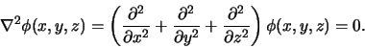

Under certain circumstances it is possible to write the solution in the product form
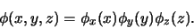

In this case the Laplace equation becomes
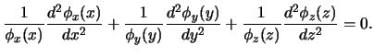 |  |  | (69)

This implies that 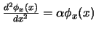, 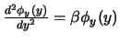and 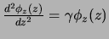with 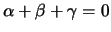. That is, the three dimential partial differential equation separates into three one dimential ordinary diffrential equation with a constraint. The constraint on , and implies that at least one of them is negative or one of them is positive. Or two of the functions are sinusoidal and the third is hyperbolic or two are hyperbolic and one sinusoidal. The values of , and are to be determined by boundary conditions. It should be apparant that this method is useful if the boundary conditions of the problem are imposed on rectangular box. This is the method of separation of variables.
The method of separation of variables is useful when the problem has a symmetry and there is a corresponding orthogonal coordinate system in which the Laplacian operator ( ) is separable. Generally, for such cases, there is also a set of orthonormal functions so one can expand the solution in this set. Most commonly used orthogonal coordinate systems are Cartesian, spherical and cylindrical systems. We have already discussed the Cartesian system. Later we shall discuss spherical and cylindrical systems.
As an example of Cartesian system, consider a problem in which the potential on five faces of a cube of unit length is given to be zero and on the sixth face ( chosen to be at ) is a function of x and y, say 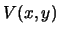. We want to find the potential everywhere inside the cube. Note that the problem can be generalized to a rectangular box of arbitrary lengths. We shall assume that the cube is in the first octant of the coordinate system. Since the potential vanishes at the end points in x and y directions, we must have and negative so that and are sinusoidal. This means and is hyperbolic. The solutions are 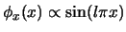, 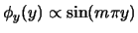and 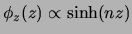where and are positive integers and 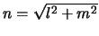. So, the solution of Laplace's equation with specified boundary conditions is
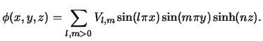 |  |  | (70)

Note that 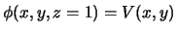. So the coefficients 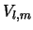's are given by
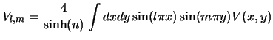 |  |  | (71)

As an example, consider 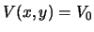. Since 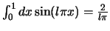for odd , we get
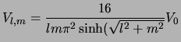 |  |  | (72)

The computed potential 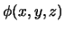is shown in Fig(2.6.2).
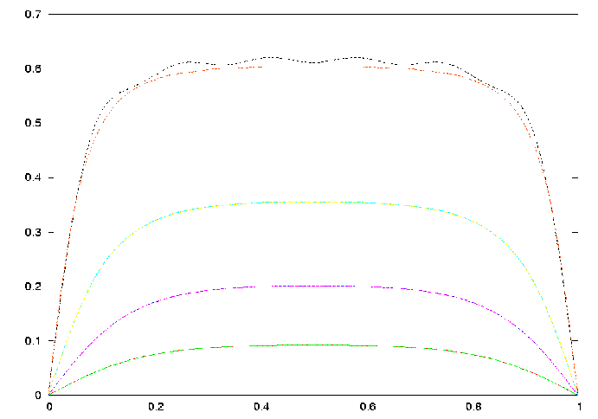
Figure 10: Calculated potential in a box of unit length with one side at held at unit potential. The curves show the potential at and increasing from 0.2 to 0.8 in steps of 0.2 units. Calculations are done for maximum and at 11 and 21. Note that larger values of and are needed as approaches unity.

Next: Separation of variables : Up: Solution of Laplace's equation Previous: Fourier series
S.C.Phatak 2007-02-20

