Recall the Fourier series (Full Range Fourier Series):
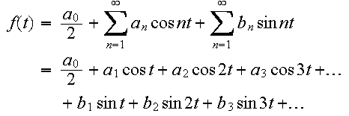
We can re-arrange this series and write it as:
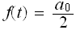+ (a₁ cos t + b₁ sin t) + (a₂ cos 2t + b₂ sin 2t) + (a₃ cos 3t + b₃ sin 3t) + ...
The term (a₁ cos t + b₁ sin t) is known as the fundamental.
The term (a₂ cos 2t + b₂ sin 2t) is called the second harmonic.
The term (a₃ cos 3t + b₃ sin 3t) is called the third harmonic, etc.

Odd Harmonics
The Fourier series will contain odd harmonics if f(t + π) = - f(t).

Example:
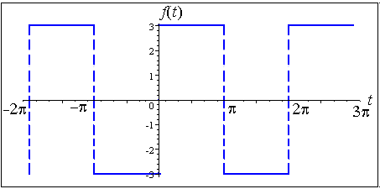
In this case, the Fourier expansion will be of the form:
a₀/2 + (a₁ cos t + b₁ sin t) + (a₃ cos 3t + b₃ sin 3t) + (a₅ cos 5t + b₅ sin 5t) + ...
All of the harmonics are odd.

Even Harmonics
The Fourier series will contain even harmonics if f(t + π) = f(t).
(That is, it has period π.)
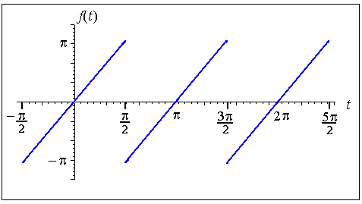
In this case, the Fourier expansion will be of the form:
a₀/2 + (a₂ cos 2t + b2 sin 2t) + (a₄ cos 4t + b₄ sin 4t) + (a₆ cos 6t + b₆ sin 6t) + ...
All of the harmonics are even.

EXAMPLES
Determine the existence of odd or even harmonics for the following functions.
(a)
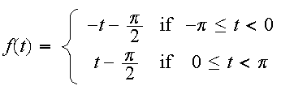
f(t) = f(t + 2π).
Answer
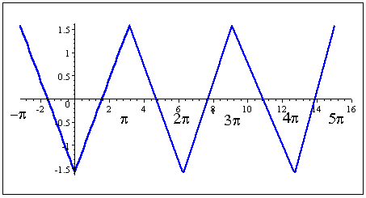
We can see from the graph that f(t + π) = - f(t).
For example, we notice that f(2) = 0.4, approximately. If we now move π units to the right (or about 2 + 3.14 = 5.14), we see that the function value is
f(5.14) = -0.4.
That is, f(t + π) = - f(t).
This same behaviour will occur for any value of t that we choose.
So the Fourier Series will have odd harmonics.
This means that in our Fourier expansion we will only see terms like the following:
a₀/2 + (a₁ cos t + b₁ sin t) + (a₃ cos 3t + b₃ sin 3t) + (a₅ cos 5t + b₅ sin 5t) + ...
[Note: Don't be confused with odd functions and odd harmonics. In this example, we have an even function (since it is symmetrical about the y-axis), but because the function has the property that f(t + π) = - f(t), then we know it has odd harmonics only. The fact that it is an even function does not affect the nature of the harmonics and can be ignored.]

Aside: Music Harmonics

Playing harmonics on a guitar. If you just lightly touch a string with the left hand and then pluck it, you hear a high pitched sound called the harmonic.[Image source.]
Music sounds "in tune" because the harmonics contained in each note sound "right" with certain other notes.
See also Line Spectrum.
(b)
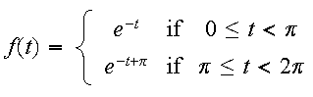

Useful Background
Check out Graphs of Exponential Functions.
f(t) = f(t + π).
Answer
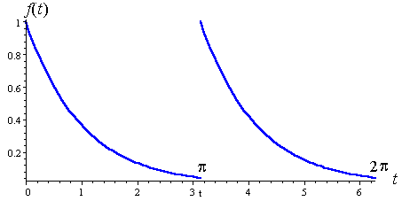
The function is periodic with period π.
So, we conclude that the Fourier series will have even harmonics, and will be of the form:
a₀/2 + (a₂ cos 2t + b2 sin 2t) + (a₄ cos 4t + b₄ sin 4t) + (a₆ cos 6t + b₆ sin 6t) + ...

