Chapter 7: High-Speed LANs

Computer networks, Client/Server computing, or distributed computing, has been steadily growing over last several decades.
Personal computers have been evolving at a rapid pace due to increases in processing power and storage capacity. Personal computers are capable of handling high quality graphics and complex multimedia applications. As the usage of these applications increase, so the demand for more powerful computers also increases.
Also, when those large files (text, pictures, video, etc.) are stored on a network and shared among users, the demand for network throughput increases considerably.
To accommodate the demand for higher speed, LAN technologies have evolved through several generations.

7.1. First Generation LANs (1980 – 1990)
(10Base5, 10Base2, 10BaseT, 4/16 Mbps Token Ring)
The first generation LANs operate at around 10 Mbps speed (10 Mbps for Ethernet and 4 or 16 Mbps for Token Rings). With this speed, companies which handle extremely large files, such as medical imaging systems, desktop publishing systems, and large database systems, would incur the problem of long delays when sharing such information over the network.
This problem naturally resulted in High-Speed LAN technologies; the second generation LANs.

7.2. Second Generation LANs (1995 -- )
(ATM, FDDI, 100BaseT, 100BaseVG)
The second generation LANs operate at 100 Mbps or higher. When the second generation LANs were worked on, several technologies emerged as candidates; Asynchronous Transfer Mode (ATM), and Fiber Distributed Data Interface (FDDI), Fast-Ethernet, and 100BaseVGAnyLan.

7.2.1 ATM (Asynchronous Transfer Mode)

ATM is a hot network technology that is a spin off from BISDN (Broadband ISDN: The next generation, higher speed ISDN developed by CCITT in 1970s and 1980s). ATM was developed as a technology in the 2nd layer for BISDN framework. ATM was well designed and has many merits and the networking industry borrowed it and implemented as a fast frame (called as “cell” in ATM) switching. ATM is versatile enough so that it can be used on a LAN, MAN, or WAN scale. ATM uses 53-byte, fixed length cells. These small, fixed length cells can be switched by hardware rather than by software, thus allowing a very fast switching capability. ATM will be covered in detail in a later chapter. ATM works at 155Mbps and up to 622 Mbps. ATM is largely employed as backbones interconnecting LANs and also as backbones for Internet. One of the advantages of ATM is its scalability. It can be applied in the wide range of networks. Advocates of ATM predict that ATM will dominate both LAN and WAN in a long term.
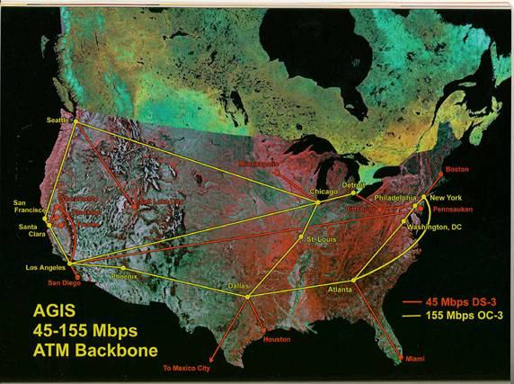
From http://www.nthelp.com/images/agis.jpg

7.2.1 FDDI (Fiber Distributed Data Interface)

FDDI (Fiber Distributed Data Interface) is an ANSI standard (ANSI X3T12) that has found its niche market as a reliable, high-speed backbone networks. It operates at a rate of 100 Mbps mainly on fiber optic cables but it can also run on copper cables (CDDI). It can support up to 500 stations on a single network. FDDI is highly reliability because FDDI networks consist of two counter-rotating rings. These dual rings are designed to back each other up, so should something go wrong on the network, an alternate path can be found quickly.

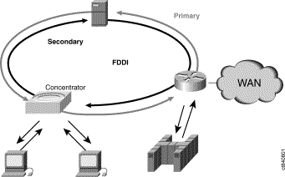
Dual Rings of FDDI

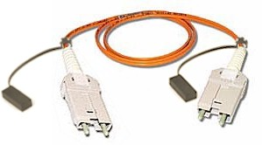
FDDI cable

The following two figures illustrate how the failures are handled by the dual ring mechanism.

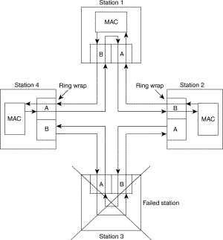
A station’s failure is handled by wrapping

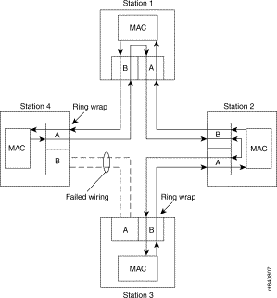
A fiber wire problem is handled by wrapping

For more detail, read from http://www.cisco.com/univercd/cc/td/doc/cisintwk/ito_doc/fddi.htm

FDDI, once touted to dominate the second generation LAN (100 Mbps) technology did not gain its popularity mainly due to 100 Mbps Ethernet and ATM.

7.2.2 100Base-T (IEEE 802.3u)

100BaseT, sometimes called as “fast Ethernet”, is a simple extension of the existing 10 Mbps Ethernet technology. It runs 10 times faster and still uses CSMA/CD as the MAC layer protocol. The name "100Base-T" refers collectively to the set of specifications and media standards for 100 Mb/s Ethernet. 10Base-T is an IEEE standard numbered as “802.3u”. Four 100 Mb/s media standards have been defined: 100Base-TX, 100Base-FX, 100Base-T4, and 100Base-T2.

a) 100Base-TX
100Base-TX is100 Mb/s Ethernet over two pairs of Category 5 UTP or Category 1 STP cables. It uses one pair of wires for transmitting, and the other pair for receiving data. Ordinary Ethernet cabling (IEEE 568) has 4 pairs of UTP. Two pairs are used for data but the other two pairs must remain unused since 100Base-TX is not designed to tolerate the crosstalk. 100Base-TX uses the same RJ45 connector as 10BaseT. 100Base-TX specifies Category 5 UTP cabling and one segment can run up to 100 meters.
100Base-TX uses “4B/5B” encoding scheme borrowed from FDDI. 4B/5B encoding requires 125 MBaud for the transmission of 100 Mbps. The 125 MBaud equates to the bandwidth requirement of 62.5 MHz which is within the 100 MHz bandwidth support by Category 5 cabling. 100Base-TX uses the same RJ45 connectors as 10BaseT.
Two 100Base-TX NICs can be directly connected each other without a 100Base-TX hub. In this case, a special “Crossover cable” must be used. A Crossover cable is made such that the sending pair of a station is cross-over wired to the receiving pair on the other station. When attaching a NIC to a hub, a normal “Straight through” cable is used and the crossover function is done by a hub.
The independent transmit and receive pairs of the 100Base-TX cabling allow the optional full-duplex mode of operation. To support full-duplex mode, both the NIC and the hub must be capable of, and be configured for, full-duplex operation.

b) 100Base-FX
100Base-FX is essentially a fiber version of 100Base-TX. It uses two-strand 62.5/125 micron multi- or single-mode optical fiber cables. It allows maximum segment lengths of 412 meters for half-duplex links, and 2000 meters or more for full-duplex links. 100Base-FX uses 4B/5B encoding. Typically used fiber in 100Base-FX is known as “62.5/125” which designates the sizes of the core and the cladding. It allows optional full-duplex mode.

c) 100Base-T4
It is 100 Mbps over 4 pairs of Category 3 or better cables but it is mainly designed to use the inexpensive, preexisting Category 3 cables as opposed to Category 5 cables which may require new installation for many existing buildings.
Of the 4 pairs, one pair is dedicated to transmit, one pair to receive, and the remaining two pairs are for bidirectional pairs that are used either to transmit or receive. In this manner, there is one dedicated pair is always listening from the medium and thus allow collisions to be detected. Three remaining pairs are used to carry 33.333… Mbps each, therefore achieving the aggregated speed of 100 Mbps. Each segment can run up to 100 meters long.
The "8B6T" signal encoding scheme is used in which 8 bits of binary data are converted into 6 "ternary" signals. A ternary signal can have one of three values: -1, 0, and +1.
100Base-T4 does not support the full-duplex mode of operation since it cannot support simultaneous transmit and receive at 100 Mb/s.

d) 100Base-T2
It is 100 Mbps over 2 pairs of Category 3 cables. 100Base-T2 uses a transmission scheme called as "dual duplex baseband transmission" which transmits data over each wire pair in each direction simultaneously. It uses a signal encoding scheme called "Five-level Pulse Amplitude Modulation", or PAM5x5.
The 100Base-T2 standard was approved in March 1997, and is not widely used at this time.

7.2.3 100BaseVGAnyLan (IEEE 802.12)

When the second generation LANs were being researched, in the fast Ethernet arena, two competing technologies emerged; 100Base-T (100Base-Tx, 100Base-Fx, …) and 100BaseVGAnyLan.
100BaseVGAnyLan does not use CSMA/CD, instead it uses 4 pairs of Category 3 UTP wires and eliminates collision altogether. The MAC layer is named as Demand Priority. 100VG-AnyLAN will also support both Ethernet and Token-Ring transmissions which makes it more complex and cost more.
Without collisions, it can support the time-sensitive (isochronous) multimedia traffic such as real-time voice and video.
100BaseVGAnyLan lost its competition against 100Base-T technology. The main reasons are; Ethernet (CSMA/CD) is an existing, proven technology and there is huge installed base and experience. Also, 100Base-T can coexist with old 10 Mbps Ethernets without any modifications to the existing networks. Also, 100Base-T is cheaper.
Ethernets still dominate even in the second generation LANs. Some experts say that ATM would become the network technology of choice in the long term which should still be seen to happen.

7.3 Third Generation LANs (1000Base-X)
(1000Base-LX, 1000Base-SX, 1000Base-CX, 1000Base-T)

The third generation Ethernets are at the speed of 1000 Mbps and the identifier “1000Base-X” refers collectively to the three standards; 1000Base-LX, 1000Base-SX, 1000Base-CX. These three are different in physical layer specifications that were adopted from the ANSI X.3.230-1994 standard for Fiber Channels. Fiber Channel is the name of an integrated set of standards are developed by the American National Standards Institute (ANSI). After 1000Base-X standards came out, 1000Base-T followed.
Before we discuss the fiber channel technology, let’s identify two basic types of communications; communication between computers p-(=networks), communication between a computer and peripheral devices (=channels). A channel provides a direct or switched point-to-point connection between communicating devices. A channel usually provides a high speed transfer with low overhead and hardware-intensive (closely tied to hardware). A network is made up of distributed communicating devices such as workstations, servers, and various devices such as printers, faxes, etc.) with higher overhead since it is software-intensive (most of operations done in software).
Fiber channel is an attempt to combine the better aspects of the two. It is designed to meet the needs of both; channels and networks.

a) 1000Base-LX
1000Base-LX uses long wave length lasers (between 1270 to 1355 nanometers) over fiber optic cables. The “L” stands for “Long” in long wave length lasers. Both multi-mode and single mode fibers can be used. The long wave length can go longer distance than short wave length but more expensive. 1000Base-LX supports both half-duplex and full-duplex modes. It uses 8B/10B encoding as in 100Base-T technologies.

b) 1000Base-SX
1000Base-SX uses short wave length lasers (between 770 to 860 nanometers) and the “S” stands for “Short wave length”. Unlike 1000Base-LX, it supports only the multi-mode fibers. It supports both half-duplex and full-duplex modes and uses 8B/10B codes.

c) 1000Base-CX
1000Base-CX uses special shielded balanced copper cables. They also called as “twinax” cables or “short haul copper”. The maximum segment length is only 25 meters. It supports both half-duplex and full-duplex modes and uses 8B/10B codes.

d) 1000Base-T
1000Base-T standard came in 1999 and it is numbered as IEEE 802.ab. 1000Base-T supports 1000 Mbps over balanced Category 5 UTP cables with the maximum segment length of 100 meters.
It employes full-duplex baseband transmission over 4 pairs of balanced Category 5 cables where each pair achieves 250 Mbps. Transmitted data and received data travel on the same wire pairs at the same time (full-duplex mode). The 1000BASE-T standard makes use of two signaling methods already used in earlier IEEE standards: 100BASE-TX (125 Mbaud three level baseband signaling) and 100BASE-T2 (25 Mbaud PAM5 baseband signaling.)

http://www.techfest.com/networking/lan/ethernet4.htm#4.2.4

7.4 Fourth Generation LANs (10GbE)

10Gigabit LAN standard already came out in 2002 as IEEE 802.3ae. The following is the description from IEEE.
From http://standards.ieee.org/announcements/8023aeapp.html

IEEE Approves 10 Gbit/s Ethernet Standard, Raising Operating Speed 10X and Adding Connectivity to WANs and MANs
Contact:
Karen McCabe +1 732 562 3824, k.mccabe@ieee.org
PISCATAWAY, N.J., 18 June 2002 The world of Ethernet communications just got faster and more connected. IEEE Standard 802.3ae™, a new standard from the Institute of Electrical and Electronics Engineers, extends the speed of Ethernet operations by an order of magnitude to 10 Gbit/s and makes provision for linking Ethernet local area networks (LANs) to municipal and wide area networks (MANs and WANs). The standard reflects Ethernet's ongoing evolution toward higher speed as network and Internet traffic continue to expand dramatically.
IEEE 802.3ae™, "Media Access Control Parameters, Physical Layers and Management Parameters for 10 Gb/s Operation," was approved by the IEEE Standards Association (IEEE-SA) Standards Board on June 13. Work on the standard began in early 1999 and has involved hundreds of industry participants from around the world.
The new standard, which offers a straightforward upgrade path for Gigabit Ethernet backbones, is specified for fiber optic media and uses full duplex operation. Its optical interfaces provide options for single mode fibers at distances up to 40 km and for multimode fibers at distances to 300 m. The new standard uses the same management architecture as appears in earlier Ethernet standards. In enterprise applications, this will allow most users to leverage their existing Ethernet investments when switching to 10 Gbit/s operation through the reuse of their installed architecture, software and cabling.
The standard reaches beyond Ethernet's traditional LAN space and enables easy connection to other networking technologies. An optional WAN physical layer allows 10 Gbit/s Ethernet links to be extended over MAN and WAN distances. The WAN PHY maps the Ethernet frames into a SONET/SDH (Synchronous Optical Network/ Synchronous Digital Hierarchy) payload. As a result, service providers can create high-speed, longer-distance Ethernet links at a competitive cost by making use of deployed infrastructure.
"The standard fosters end-to-end network convergence at high speed," says Bob Grow, Chair of the IEEE 802.3 Working Group and a Principal Architect in the Intel Communications Group. "As the next logical step in speed for the IEEE 802.3™ standard, it expands the opportunities for current and emerging high-bandwidth applications."
Jonathan Thatcher, IEEE 802.3ae™ Task Force Chair, adds that, "the push to 10 Gbit/s is especially important for the Internet, since nearly all its traffic starts or ends on Ethernet nodes. In essence, the new standard lets users choose Ethernet speeds from 10 Mbit/s to 10 Gbit/s and still have a familiar management model throughout and consistent bridging between networks at different rates."
IEEE 802.3ae™ was sponsored by the IEEE 802 LAN/MAN Standards Committee of the IEEE Computer Society. For further information on IEEE 802 standards projects, visit http://www.ieee802.org/.
About the IEEE Standards Association
The IEEE Standards Association (IEEE-SA), a global standards-setting body, develops consensus standards through an open process that brings diverse parts of an industry together. It has a portfolio of more than 870 completed standards and more than 400 in development. IEEE-SA promotes the engineering process by creating, developing, integrating, sharing and applying knowledge about electro- and information technologies and sciences for the benefit of humanity and the profession. For further information on IEEE-SA visit: http://standards.ieee.org/.
From Chevron presentations
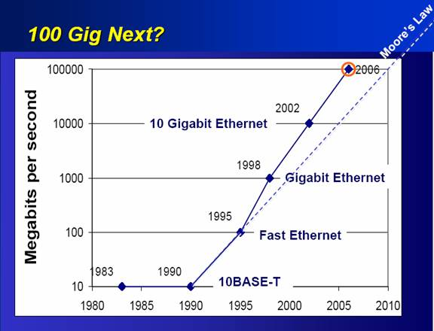

7.5 Summary on High speed LANs

It seems like the speed never stops increasing and we can see the shortening of the development cycles for newer technologies; The gap between 1st to 2nd generation was about 15 years but 2nd to 3rd and 3rd to 4th are taking only 4 years!

• 10 Mbps LANs(1st)—1980 to 1990
• 100 Mbps LANs(2nd)—1995
• 1000 Mbps LANs(3rd)—1998
• 10Giga LANs(4th)—2002

The newer generation LANs are typically used as backbones that interconnect existing slower speed LANs together and also connect high speed servers to networks. Also, from the third generations, the main media are fiber optic cables since the twisted pairs are reaching their maximum capacity.
Another important feature in newer generations is “Auto-negotiation” which makes older generation Ethernet coexist with newer generation. A newer generation Ethernet hubs (and switches) are usually equipped with the feature. A hub (or a switch) with the feature can detect the speed of incoming link and automatically adjust the port speed.
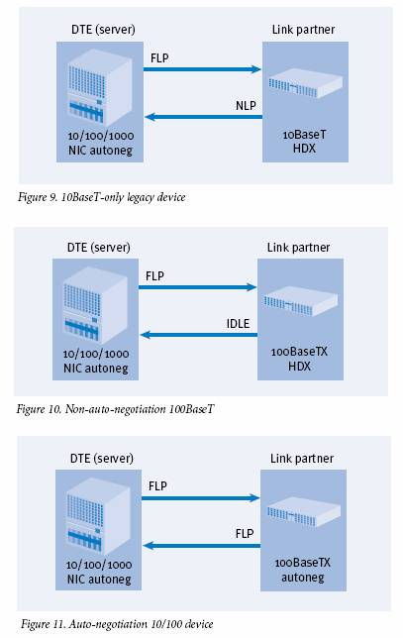
10BaseT network cards are designed to send NLP(Normal Link Pulse), sometimes called as “Heartbeat”, to notify the health of itself. The 2nd generation and higher Ethernet hubs and network cards are designed to send FLP(Fast Link Pulse) which is used to notify and detect each others speeds. Therefore, by looking at the FLP signals from its connection, a network card, a hub, or a switch can automatically adjust its speed.

**add a diagram showing backbone networks**

7.6 LAN Switches

As discussed in Chapter 6, there are two modes in LAN technologies: Shared medium LANs and Switched medium LANs. Switched medium LANs are realized by “switches”.
Switches are devices with multiple ports which are able to filter and forward packets at nearly the speed of Ethernet (“wirespeed”). Switches are equipped not only with Ethernet ports but also with the necessary logic for the Data Link Layer (2ndlayer of OSI model).
Switches can be employed in any LAN technology; Ethernet switches, Token Ring switches, FDDI switches.
Let’s concentrate on Ethernet switches since they are the most widely used ones. There are two kinds of Ethernet switches; Store-and-forward switches and Cut-through switches.

• Store-and-forward switches: Ethernet frames are received and error is checked and if no error is detected then store the frame in buffer and forward to the destination station.
• Cut-through switches: Store-and-forward switches become inefficient and also slow since they should receive the entire frame and check error then forward. Cut-through switches look at the destination address as a frame comes in and forwards to destination without waiting to receive the whole frame.

Ethernet switches are used as interim solutions before upgrading existing Ethernet to a next generation. For example, with existing 10BaseT Ethernets, you can exchange the 10BaseT hub with 10BaseT switches. Then the network throughput will increase instantly since switches virtually eliminate collisions.
