It is all in your head!
Overview of speech mechanics:

The easiest way to master something is to become familiar with it. The images below depict the parts of the speech mechanism that we all use everyday but may not know how or why we do so.
It is the harmonious coordination of the various parts of the mechanism: tongue, teeth, lips, and vocal cords that allows us to communicate orally by producing a wide variety of sounds. Everything from the ear-piercing screams we hear in horror films to the subtle cooing of infants makes its way through the oral apparatus. Rarely do we give the slightest thought to different functions of the vocal system such as the larynx, nasal cavity, and diaphragm, unless you happen to be an opera singer. By becoming acquainted with the various instruments we use unconsciously on a daily basis, we can become more adept at conducting the oral orchestra into producing a symphony of sound pleasing to the most discriminate of interlocutors.
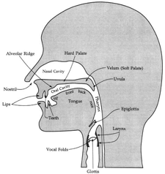
Figure 1
In this lateral view of the head (Figure 1), we see the layout of the various parts of the speech mechanism. As air is pushed out of the lungs by the diaphragm, its frequency (pitch, tone, intonation) is altered initially by the vocal cords as they pass through the larynx; the air then passes through the pharynx and exits through the oral and nasal cavities.
The nasal cavity resonates and is responsible for giving the voice a specific tambour or color. Just like the warm low tones from a cello or the shrill highs from a violin, the size and shape of the nasal cavity affects the “warmth” of our voices. We have all heard people with “nasally” mouse-like voices, or singers that sound hollow as singing with a paper bag over their heads. For our purposes, we need know how to control the passage of air through the speech mechanism and, especially in the case of French, the nasal cavity in order to produce the sound of nasalized vowels accurately.
The oral cavity is where the majority of the refining of individual phonemes (sounds) occurs. A phoneme is the smallest unit of sound. As you can see in Figure 2, the oral cavity is divided into many sections. These sections create a three-dimensional instrument that, when played properly, allows the speaker to enunciate the vast variation of sounds that exist in the myriad of human languages.
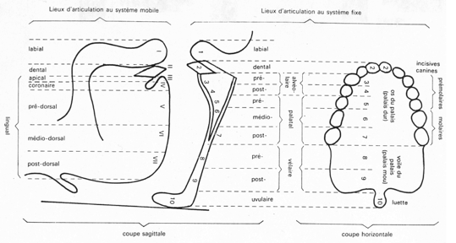
Figure 2
Now that we have taken a quick look at the anatomical construction of the oral mechanism, let us start our focused study of French pronunciation by looking at the most important group of sounds that are the foundation of the French accent: the vowels.

