oice-Over-Internet Protocol | site map

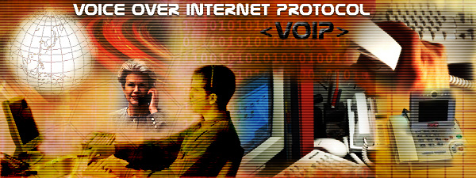
IP-Enabled Services
Voice over Internet Protocol (VoIP), is a technology that allows you to make voice calls using a broadband Internet connection instead of a regular (or analog) phone line. Some VoIP services may only allow you to call other people using the same service, but others may allow you to call anyone who has a telephone number - including local, long distance, mobile, and international numbers. Also, while some VoIP services only work over your computer or a special VoIP phone, other services allow you to use a traditional phone connected to a VoIP adapter.

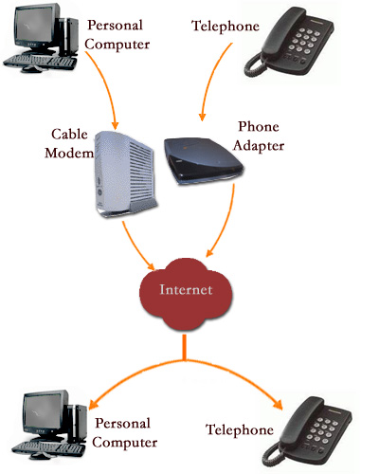
Frequently Asked Questions
How VoIP / Internet Voice Works
VoIP services convert your voice into a digital signal that travels over the Internet. If you are calling a regular phone number, the signal is converted to a regular telephone signal before it reaches the destination. VoIP can allow you to make a call directly from a computer, a special VoIP phone, or a traditional phone connected to a special adapter. In addition, wireless "hot spots" in locations such as airports, parks, and cafes allow you to connect to the Internet and may enable you to use VoIP service wirelessly.
What Kind of Equipment Do I Need?
A broadband (high speed Internet) connection is required. This can be through a cable modem, or high speed services such as DSL or a local area network. A computer, adaptor, or specialized phone is required.Some VoIP services only work over your computer or a special VoIP phone, while other services allow you to use a traditional phone connected to a VoIP adapter. If you use your computer, you will need some software and an inexpensive microphone. Special VoIP phones plug directly into your broadband connection and operate largely like a traditional telephone. If you use a telephone with a VoIP adapter, you'll be able to dial just as you always have, and the service provider may also provide a dial tone.
Is there a difference between making a Local Call and a Long Distance Call?
Some VoIP providers offer their services for free, normally only for calls to other subscribers to the service. Your VoIP provider may permit you to select an area code different from the area in which you live. It also means that people who call you may incur long distance charges depending on their area code and service.
Some VoIP providers charge for a long distance call to a number outside your calling area, similar to existing, traditional wireline telephone service. Other VoIP providers permit you to call anywhere at a flat rate for a fixed number of minutes.
If I have VoIP service, who can I call?
Depending upon your service, you might be limited only to other subscribers to the service, or you may be able to call anyone who has a telephone number - including local, long distance, mobile, and international numbers. If you are calling someone who has a regular analog phone, that person does not need any special equipment to talk to you. Some VoIP services may allow you to speak with more than one person at a time.
What Are Some Advantages of VoIP?
Some VoIP services offer features and services that are not available with a traditional phone, or are available but only for an additional fee. You may also be able to avoid paying for both a broadband connection and a traditional telephone line.
What Are Some disadvantages of VoIP?
If you're considering replacing your traditional telephone service with VoIP, there are some possible differences:
Some VoIP services don't work during power outages and the service provider may not offer backup power.
Not all VoIP services connect directly to emergency services through 9-1-1. For additional information, see VoIP & 911 Advisory.
VoIP providers may or may not offer directory assistance/white page listings.
Can I use my Computer While I talk on the Phone?
In most cases, yes.
Can I Take My Phone Adapter with me When I Travel?
Some VoIP service providers offer services that can be used wherever a high speed Internet connection available. Using a VoIP service from a new location may impact your ability to connect directly to emergency services through 9-1-1. For additional information, see VoIP & 911 Advisory.
Does my Computer Have to be Turned on?
Only if your service requires you to make calls using your computer. All VoIP services require your broadband Internet connection to be active.
How Do I Know If I have a VoIP phone Call?
If you have a special VoIP phone or a regular telephone connected to a VoIP adapter, the phone will ring like a traditional telephone. If your VoIP service requires you to make calls using your computer, the software supplied by your service provider will alert you when you have an incoming call.
Does the FCC Regulate VoIP?
In June 2005 the FCC imposed 911 obligations on providers of “interconnected” VoIP services – VoIP services that allow users generally to make calls to and receive calls from the regular telephone network. You should know, however, that 911 calls using VoIP are handled differently than 911 calls using your regular telephone service. Please see our consumer fact sheet on VoIP and 911 services for complete information on these differences.
In addition, the FCC requires interconnected VoIP providers to comply with the Communications Assistance for Law Enforcement Act of 1994 (CALEA) and to contribute to the Universal Service Fund, which supports communications services in high-cost areas and for income-eligible telephone subscribers.
Aspects of these considerations may change with new developments in internet technology. You should always check with the VoIP service provider you choose to confirm any advantages and limitations to their service.
For more information about VoIP see our factsheet (pdf file).

